System Architecture

Campus Placement

Abhishek Rajesh Saste

System Architecture

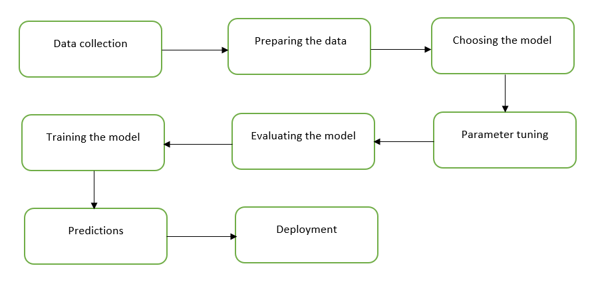

The process of building the machine learning model includes many steps, which are explained in the figure above. This also accounts for the system architecture of this project.

1. Data collection

Collecting the relevant data is the most important part of building any machine-learning model. It is necessary to have data that is not outdated with accurate features. The accuracy of any machine-learning model depends on the quality of the data, the better the data the more accurate model is built.

1. Preparing the data

After the data has been collected, it needs to be prepared in a way that any machine-learning model can understand it. This includes exploring the data and understanding its features, and data cleaning wherein the null values and outliers are refined. When the data is cleaned and brought in a format that the machine-learning models can understand, it is then split into training and testing. Here the training set is the one from which the models learn and the testing split is then used to test the accuracy of the model learned from the training set.

1. Choosing the model

Many algorithms can be used for the respective cases to predict the outcomes, but their accuracies vary. So choosing the correct model which will give the highest accuracy is a must. This can be done using the Grid Search cross-validation technique, which allows the user to find the model with the highest accuracy by comparing the results with other models.

1. Parameter tuning

Firstly the models are checked on all the default values and their corresponding accuracy is obtained. To increase the accuracy the parameters of the models can be tuned or changed. This allows the user to compare and understand the behavior of the model’s accuracy on default values and changing the parameters.

1. Training the model

The model with the highest accuracy obtained from the above process is then trained on the training split with the parameters that gave the highest accuracy for the respective model.

1. Evaluating the model

The trained model is then evaluated on the test spilt to check how accurately the model can predict the outcomes on the never seen data. Hence the model can be saved and used for predictions once it is trained and evaluated.

1. Predictions

Using the saved model, the user can develop an app or a website that makes predictions according to the requirements of a user. If this is not to be considered the working of the model can be also visualized on the confusion matrix.

1. Deployment

The developed app or website can be then deployed for use on various cloud platforms such as AWS, Azure etc.